**FIBO Primer**

*EDM Council*

*31 December 2018*





# Summary of this Primer

The purpose of this Primer is to inform all potential users of FIBO about how to find its content, how to understand its content and how to use and extend its content. Clearly, given the massive content of FIBO, and the wide range of its users, this Primer is only the first step in this process.

While FIBO gives something of value to everyone in the Finance Industry – for example the FIBO Glossary and Data Dictionary require no more than the ability to read English, other FIBO products require considerable knowledge and acceptance of a learning curve in the technology of the Semantic Web.

FIBO is intended for a range of users including in its simplest form as an English language Glossary that could be used to inform a bank or a regulator’s Data Dictionary, or the actual FIBO Data Dictionary could be repurposed as a bank or regulators Data Dictionary. In its most complex form, FIBO in its native Web Ontology Language (OWL), could be used as a bank’s operational ontology. There are also those external uses of FIBO such as FIBO.schema.org which uses FIBO as a reference to find specific information on the Internet.

To serve this wide array of users, FIBO is published as a variety of products in file formats and dialects ranging from HTML to JSON-LD. Currently, there are more than 9 distinct products. All are generated, or derived from the FIBO RDF/OWL System of Record.

FIBO currently consists of core Finance Industry domains including Securities and Equities, Business Entities, Derivatives and more, in modules and ontology files. There are two published releases. FIBO Development and FIBO Production. FIBO Development is released as changes are made by FIBO Content Teams. FIBO Production is released at the end of each quarter.

FIBO Development is 100% of FIBO and is certain to contain unfinished as well as carefully vetted and tested work. FIBO Development will be the preferred source for those intending to become part of the FIBO development process, and for those intending to experiment with extending FIBO on their own. FIBO Production consists of those FIBO Domains that have been vetted and tested to the best of the FIBO Team’s ability with state of the art tools. This release of FIBO Production includes Foundations, Financial Business and Commerce, Business Entities, Loans, Indices and Indicators, Derivatives, and Securities and Equities.

Taking full advantage of FIBO is best achieved through the suite of FIBO tools underlying the FIBO Build-Test-Deploy-Maintain (BTDM) Methodology. Access and instructions are available at <https://spec.edmcouncil.org/>

FIBO, as described above, is available at <https://spec.edmcouncil.org/fibo/> From this site, all, or a part, of FIBO can be downloaded as the products described above.

Contents

Summary of this Primer 2

1. Introduction 4

1.1. What is FIBO? 4

1.2. What is an Ontology? 4

1.3. FIBO Structure 6

1.4. FIBO Maturity Levels 6

FIBO Source Maturity Levels 6

FIBO Publication 7

2. Accessing and Using FIBO 7

2.1. Using FIBO 7

2.2. FIBO Human-Readable Products Glossary (web searchable and downloadable HTML and/or spread sheet), Data Dictionary (searchable and downloadable, VOWL, UML Models), FIBOPedia 8

Glossary 8

UML Models and Diagrams 10

2.3. FIBO Machine-Readable Products (Vocabulary, Ontology) 11

FIBO Vocabulary (SKOS) 11

FIBO Ontology Files (OWL) 11

Using FIBO OWL Ontology Files Online 11

Schema.org 13

3. APPENDIX A - Usage Examples 14

Example 1 14

Example 2 Mapping Sources in Different Formats (Integration; reporting) 15

4. Appendix B Understanding SMIF UML Diagrams 17

5. Appendix C - Additional Training Materials 20

# Introduction

## What is FIBO?

The Financial Industry Business Ontology (FIBO) is the industry standard resource for the definitions of business concepts in the financial services industry. It is developed and hosted by the Enterprise Data Management Council (EDMC) and is published in a number for formats for operating use and for business definitions. It is also standardized through the Object Management Group (OMG).

FIBO is developed as a series of *ontologies* in the Web Ontology Language (OWL). As such it is not a data model but a representation of the “things in the world” of financial services. The use of logic ensures that each real-world concept is framed in a way that is unambiguous and that is readable both by humans and machines. These common concepts have been reviewed by EDM Council member firms over a period of years and represent a consensus of the common concepts as understood in the industry and as reflected in industry data models and message standards.

FIBO is developed according to a rigorous and well-defined process, referred to as the “Build-Test-Deploy-Maintain” [methodology](https://spec.edmcouncil.org/fibo/doc/FIBO_BTDM.pdf). A definitive document for that process is available [here](https://www.edmcouncil.org/downloads/2015_06_30_EDMC_FIBO_build_test_deploy_maintain.pdf) and should be referred to by anyone participating in FIBO development activities. In essence, the FIBO ontologies are developed and maintained by FIBO Content Teams which are coordinated by a single FIBO Leadership Team (FLT), with process and automation support provided by a FIBO Process team.

[FIBO Frequently asked Questions](https://spec.edmcouncil.org/fibo/doc/FrequentlyAskedQuestions.pdf) (FAQ) provides many useful links to FIBO Design and Build guidelines.

## What is an Ontology?

An ontology in OWL is made up of statements about Classes (i.e., sets of things) and Properties (ways that things relate to other things). FIBO defines the sets of things that are of interest in financial business applications, and the ways that those things can relate to one another. In this way, FIBO can give meaning to any data (e.g., spreadsheets, relational databases, XML documents) that describe the business of finance. FIBO considers both Classes and Properties to be Concepts. The languages of Ontologies were originally developed by the US DoD and are codified by the World Wide Web Consortium (W3C). Their place in the continuum of Information Management is shown in the figure below.

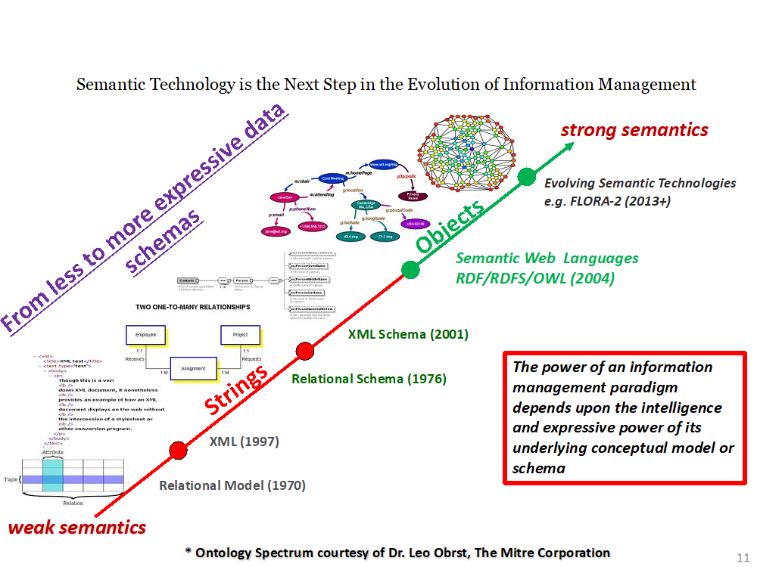

## FIBO Structure

FIBO is organized in a hierarchical directory structure to organize the ontologies. Top level directories are called *domains*; beneath that may be one or two levels of *sub-domain and then modules.*

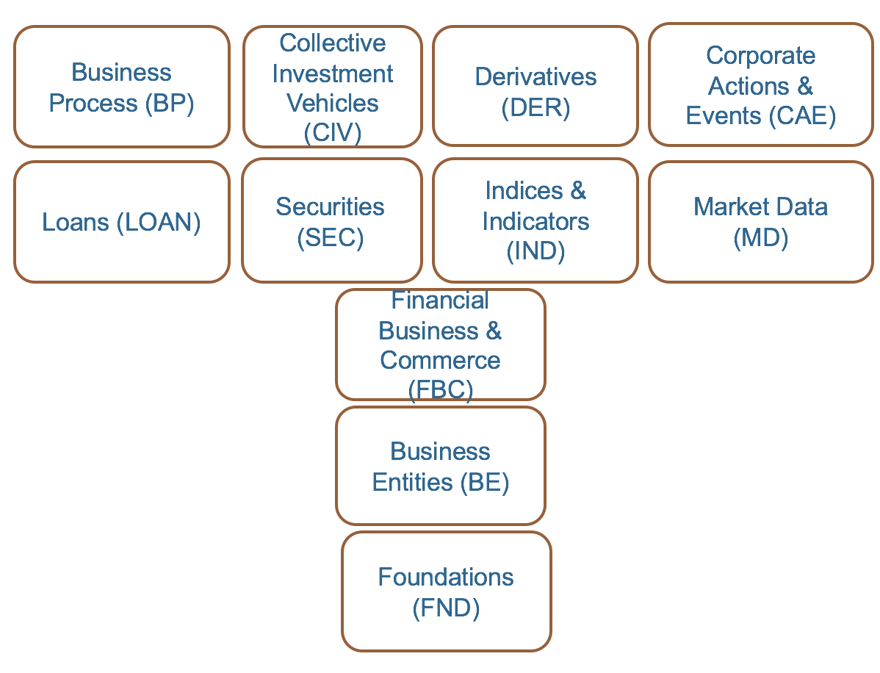

## FIBO Maturity Levels

FIBO is published at two levels, each with a complete set of artifacts, or products:

* a **Production** level, where every ontology has passed serious scrutiny for consistency, completeness and documentation. This is published at the end of each quarter
* a **Development** level, where the ontologies have passed only minimum scrutiny for referential consistency (they don’t refer to things which are undefined). This is published continuously as content is developed. It also includes updates to Production content that has not yet been published (at the end of the quarter). Casual users and developers should work with Development FIBO and comment back to the relevant FIBO Content Team through EDM Council JIRA or the feedback form on <https://spec.edmcouncil.org/>

### FIBO Source Maturity Levels

FIBO publications are built out of FIBO sources from a FIBO GitHub Repository.  FIBO sources are all in OWL and have three levels of maturity, *Informative*, *Provisional* and *Release*. One can see the maturity level in the OWL for each ontology.

**Informative**

* Informative ontologies are ones that have been considered by a content team, but have been explicitly rejected. They are included in FIBO sources because they include information, without which FIBO would fail basic referential consistency tests. Casual users should usually ignore them. Developers should consider these for information only, to determine the detailed meaning of the things that reference them.

**Provisional**

* Provisional ontologies were developed in the early days of FIBO, or have been developed by FIBO Content Teams, but have not been vetted or tested to the level of Release.

**Release**

* Release ontologies have undergone unit and integration testing, and have passed the most rigorous tests for completeness, consistency and correctness.

### FIBO Publication

FIBO publications are built from these sources through a process that involves re-writing URIs to match publication conventions, converting files into multiple standard formats, and triggering derivative products such as the Glossary and Vocabulary. The figure below shows the publication process.



# Accessing and Using FIBO

## [Using FIBO](https://spec.edmcouncil.org/fibo/)

All of FIBO can be read by humans. However, only FIBO RDF/OWL based products can be embedded in computer applications that can perform logic functions such as inferring classifications and relationships. All FIBO products below are described in more detail in this section:

* Glossary - Human-readable, cross-referenced dictionary of terms in FIBO in HTML, .csv and .xlsx.
* Data Dictionary – An
* Excel spreadsheet of FIBO terms in .csv and .xlsx (Production and unabridged)
* FIBO-Vocabulary - A machine-readable taxonomy of terms in FIBO (in extended SKOS)
* FIBOPedia - A tree structure to help users navigate into the FIBO Domains/Modules and facilitate access to the underlying content.
* Linked Data Fragments – A way of searching for a particular FIBO Triple, or executing a query
* UML Models - Machine- and human-readable UML diagrams of FIBO (using the forthcoming OMG UML profile “SMIF”) Semantic Modeling for Information Federation)
* Ontology Files – Machine-readable files in the Web Ontology Language (OWL), in a variety of different formats
* schema.org - A vocabulary for marking up web pages for search engines, which has been extended with terms taken from FIBO

The landing page for FIBO [Products](https://spec.edmcouncil.org/fibo/) has links to each of the separate Products. Within each Product a user may choose whether to see the Production or the Development version of all of FIBO, or a single ontology.

## FIBO Human-Readable Products Glossary (web searchable and downloadable HTML and/or spread sheet), Data Dictionary (searchable and downloadable, UML Models), FIBOPedia

### [Glossary](https://spec.edmcouncil.org/static/glossary/)

Generated from the OWL the FIBO glossary is a list of classes and properties defined in FIBO, including their logical definition and natural language definition as well as synonyms where available. As with all of FIBO there is a Production version of the Glossary, which includes definitions of terms that have been vetted by the FIBO content teams, as well as a Development version, which includes terms that are currently being developed.

**Class:** the primary label by which the concept is identified.

**Definition:** a written definition that has been arrived at during subject matter expert reviews of the concept, or in some cases a definition sourced from a suitable authority or publication.

**Synonym:** One or more additional labels by which the same concept is also known, for example in different business areas or different markets.

**Model-Generated Definition:** A set of logical assertions setting out what it takes for something in the world to be a member of the set represented by this concept. This is in the following parts:

* “A kind of …” identifies the one or more concepts of which this concept is a sub type.
* “A valid occurrence satisfies the following necessary conditions” introduces a list of assertions which must be true for something to be a member of that set of things; for example, that it must have at least one value (possibly of a certain type) for a given property
* “A valid occurrence may also have the following properties” introduces a list of properties that it would commonly be expected to assert about that such things even if they are not necessary conditions for set membership.

There are 3 ways to work with the FIBO Glossary.

1. Web Searchable
2. Downloadable as a .csv for working in a spreadsheet
3. Downloadable as a .xlsx for working in a spreadsheet

Web Searchable

* [*Production*](https://spec.edmcouncil.org/static/glossary/production.html)
* [*Development*](https://spec.edmcouncil.org/static/glossary/development.html)

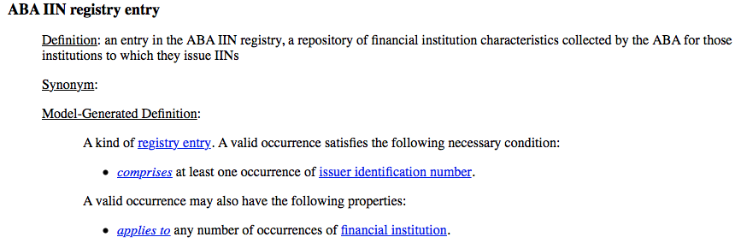

Comma Separated Values format

* [Production](https://spec.edmcouncil.org/fibo/datadictionary/master/latest/production.csv)
* [Development](https://spec.edmcouncil.org/fibo/datadictionary/master/latest/development.csv)

.xlsx format;

* [Production](https://spec.edmcouncil.org/static/datadictionary/production.xlsx)
* [Development](https://spec.edmcouncil.org/static/datadictionary/development.xlsx)

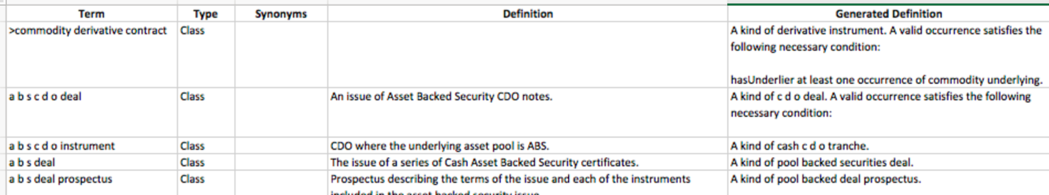

* [FIBO Data Dictionary](https://spec.edmcouncil.org/fibo/datadictionary/master/2018Q2/)

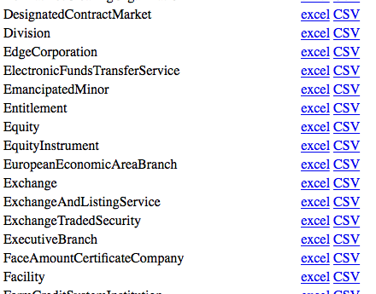FIBO as a more traditional data dictionary searchable from the Web and down loadable in .xlsx. Provides a summary of each of the classes in FIBO, with the operational fields (using the data dictionary word; called "properties" in OWL) that apply to each of them. Below is a sample from the FIBO Data Dictionary launch page and an example from a search on Equity in the [FIBO Unabridged Data Dictionary](https://spec.edmcouncil.org/static/datadictionary/master_data_dictionary_unabridged.xlsx). A click on a file will download it to a browser. It must be opened from the browser.

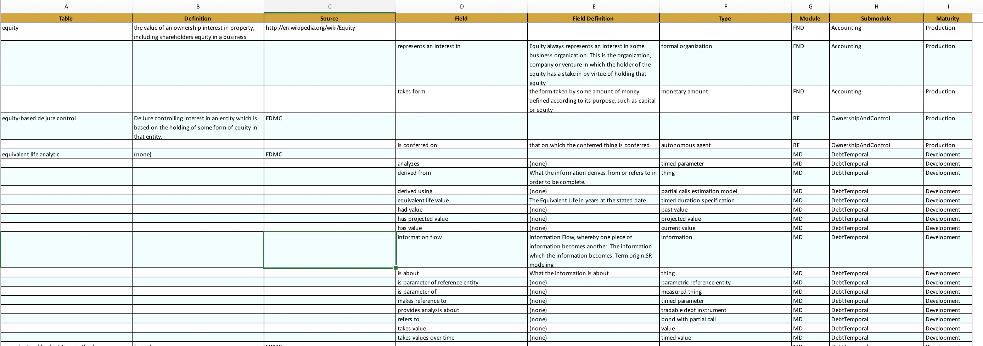

### [UML Models and Diagrams](https://spec.edmcouncil.org/static/smif/Production SMIF UML Diagrams-new links.html)

FIBO makes use of a UML-based modeling language for the creation of conceptual models which is part of a larger forthcoming standard called Semantic Information Modeling for Federation (SMIF). The specific flavor of SMIF used in the current Products is supported by Cameo Concept Modeler (CCM), a MagicDraw plug-in from NoMagic Inc. CCM may be used to generate, import and edit OWL ontologies.

As further implementations of [SMIF](https://github.com/ModelDriven/SIMF) become available, these tool formats will also be provided as FIBO Products. Some understanding of SMIF will be required for anyone browsing, reading or extending these models.

The UML models may be accessed in two ways: as diagrams on the published HTML pages, and as a downloadable stand-alone copy of the UML file. Appendix B provides an explanation of the different flavors of UML diagrams used for FIBO together with examples.

### 

https://ssl.gstatic.com/ui/v1/icons/mail/images/cleardot.gif

## 2.3. FIBO Machine-Readable Products (Vocabulary, Ontology)

### FIBO Vocabulary ([SKOS](https://spec.edmcouncil.org/static/vocabulary/))

This is a machine-readable file giving terms, definitions and relationships. These are in an extended Simple Knowledge Organization System (SKOS) format, where FIBO relationships are represented as sub-properties of the standard *isRelatedTo* property, rather than as SKOS Concepts.

The FIBO Vocabulary machine-readable files are intended to provide input to a range of tools, usually characterized as Glossary or Vocabulary tools. These tools are generally used to provide further business-facing representations of the content of these files.

### FIBO Ontology Files ([OWL](https://spec.edmcouncil.org/fibo/ontology/master/latest/tree.html))

These may be loaded into any tool that consumes the Web Ontology Language, and is available in the following formats:

* RDF/XML (.rdf)
* Turtle (.ttl)
* JSON-LD (.jsonld)
* NQuads (nq.zip), with a named graph per ontology

These may be used offline after downloading the required OWL files, or on-line as a “Follow-your-nose” implementation. Follow-you-nose is described below.

This part of <https://spec.edmcouncil.org/fibo/> has comprehensive information on the use of Vendor tools and a list of all FIBO supported formats

### Using FIBO OWL Ontology Files Online

The FIBO Ontology is available online using the follow-your-nose pattern. This means that tools that use this pattern can read FIBO directly from the web. This ensures that you are always viewing the latest version of FIBO. Keep in mind, that when viewing FIBO in this way, that any edits you make to FIBO will only be reflected in your own copy, and won't be saved for others to see. FIBO is also available for offline use by downloading a .zip of the current state. FIBO is updated every three months, so any such offline downloaded version will quickly be out of date. FIBO is published using the Web Ontology Language (OWL). There are a number of tools available, both commercial and open source, that can read and edit FIBO. We provide instructions for the most common ones.

[FIBO Linked Data Fragments](http://fragments.edmcouncil.org/)

To increase the availability of FIBO triples from our Linked Data Fragment server are available [here](http://fragments.edmcouncil.org/):  A linked data fragment  client can be pointed to that location, one can obtain a client and server implementation [here:](http://linkeddatafragments.org/)

The purpose of this server is to enable intelligent clients that can process triples in client side SPARQL. A triple pattern specification is very lightweight, and still allows SPARQL endpoint like access of data. One can look at this protocol method as sitting between a full RDF dump file and a SPARQL endpoint. Somewhere in the middle of the spectrum. It is planned to offer client implementation from this server after some further testing and finding some handy queries to prepopulate.

 Other fragments servers in production can be found [here](http://data.linkeddatafragments.org/):

[FIBOPedia](https://spec.edmcouncil.org/static/fibopedia/FIBOpedia.html)

FIBOPedia is designed as a tree structure to help users navigate into the FIBO Domains/Modules and to facilitate access to the underlying content. Hovering your mouse over any of the module labels displays a description of the content and its status. [Clicking on the label](https://spec.edmcouncil.org/fibo/widoco/master/latest/BE/Corporations/Corporations/index-en.html) will take you directly to a list of imported ontologies, details about related classes and properties as well as a graphical visualization of the ontology using the same VOWL described earlier.

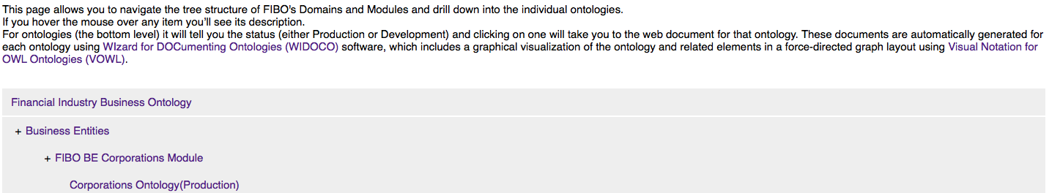

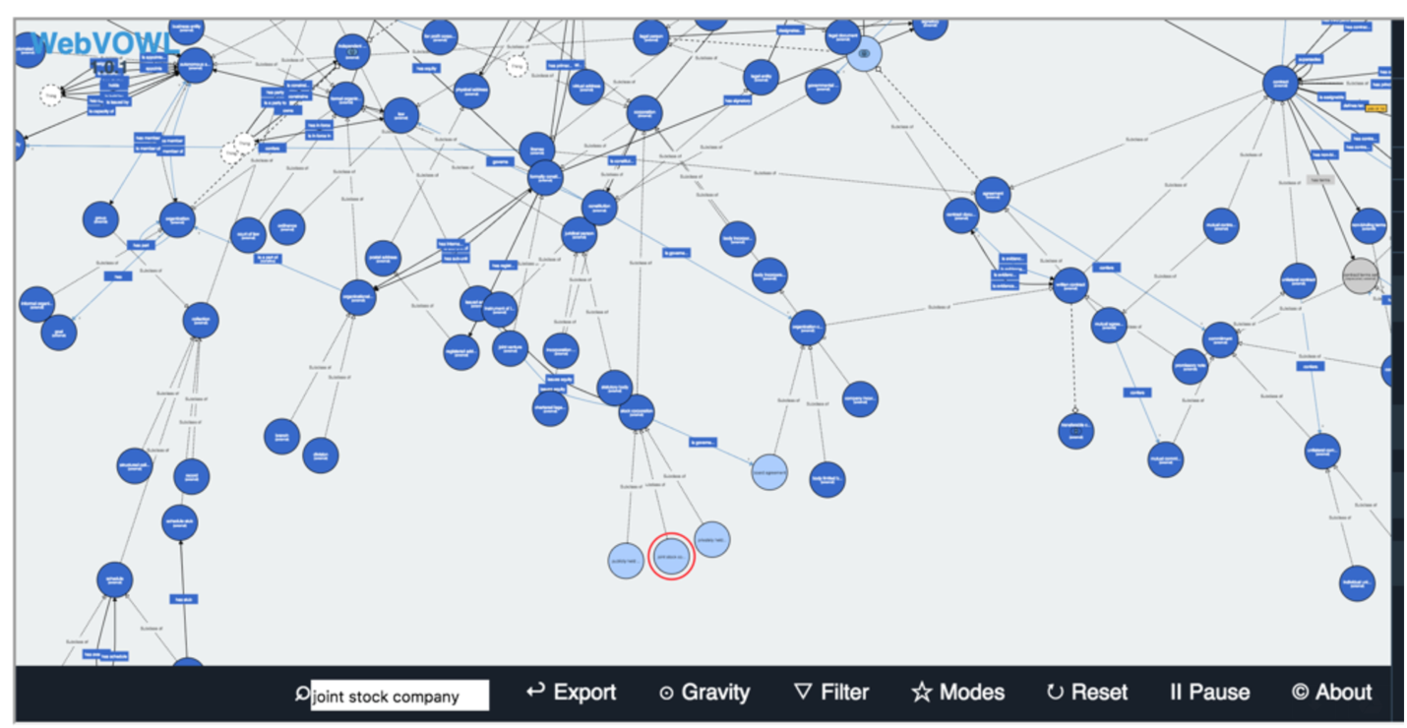

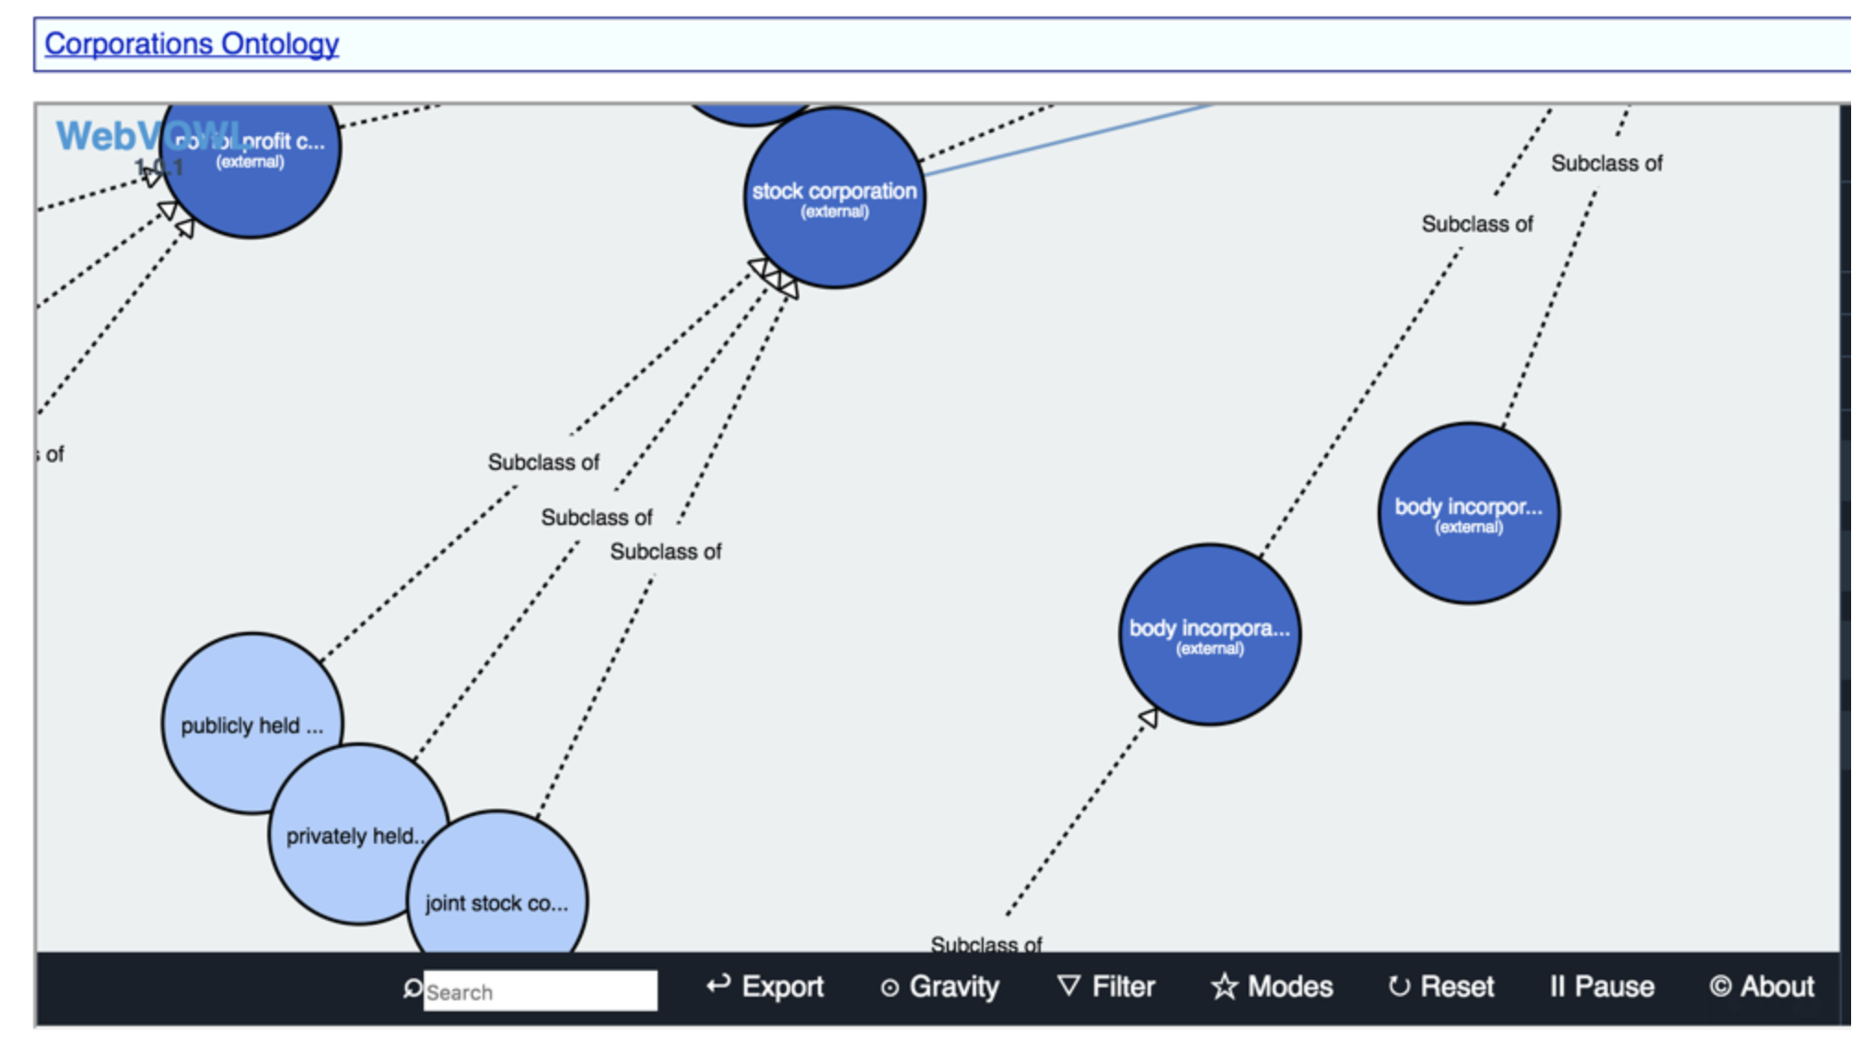

What we have found as a good practice is:

 1. Set the degree of collapsing to 0

2. Zoom out - using two finger motion (down) or mouse wheel

3. You should see the local classes in light blue

4. Type the class you are searching for in the search box. It gets highlighted in Red. (For corporation’s ontology try - joint stock company as in the example below

5. You can zoom in to the specific area.

### 

### [Schema.org](http://schema.org/docs/financial.html)

Shema.org includes concepts derived from FIBO, along with a FIBO-specific extension to schema.org itself with further FIBO concepts. These are published in Microdata, RDFa and JSON-LD formats.

# APPENDIX A - Usage Examples

This section gives real-world examples that may use a combination of the business-facing and technical FIBO products described above.

### Example 1

**Extending FIBO for Regulatory and Managerial Reporting Bonds and Equities**

Oliver Browne, Nenad Krdzavac, Philip O’Reilly, Mark Hutchinson, David Saul, Dáire Lawlor, Daragh McGetrick

Synopsis of work presented for FIBO at EDW Conference in Atlanta, GA

Ontologies are fast becoming a key alternative to database redesign and extension as legacy information systems are wrapped in semantic web forms to be maintained in a traditional financial institution setting. To this end, State Street Corporation and University College Cork set about investigating the use of the semantic web to enable enriched reporting over existing database systems for managerial fund level data views and regulatory returns.

To begin, we converted a collection of SQL outputs in csv format into XSLT. This allowed us to use our database schema and business logic documentation to map to a snapshot of the Financial Industry Business Ontology (FIBO). We found that the existing FIBO standard allowed us to map most instruments and their properties in our sample data barring some esoteric instruments, such as real estate investment trusts, which were added as classes to the standard.

Once our initial standard level of data had been mapped to FIBO, we began implementing our enterprise level ontology. This allowed to map data specific to the enterprise and internal management. Items such as data source, fund manager and investment advisors belong in this view of the data.

Finally, we used the Central Bank of Ireland money market investment fund (MMIF) return as a template for regulatory returns of bond and equity fund data. We incorporated the regulations involved in preparing and filing the returns for this template and extended them using the FIBO standard. This was a significant benefit of the ontological approach as it is expensive or even impossible to manipulate a traditional relational databases core schema. Importantly, the use of FIBO allowed us to create a regulatory return without the need for changes to the database schema or manual aggregation of data.

To prepare these returns and reports, several tools were utilized. These included Stardog, Jena API, Pellet API, Java FX, TopBraid and eclipse. Reports were prepared using SPARQL queries over the data stored in Stardog. A key benefit of ontologies is the ability to perform flexible data queries using SPARQL. For example, in a traditional relational database environment, if a regulator asks for all exposures to a counterparty, this involves a data dump of system data and manual aggregation of exposures. SPARQL queries allow you to query the entire knowledge graph and return all exposures without manual intervention.

The final major contribution of ontologies is in the use of reasoning tools. This allows users to test the validity and logical consistency of the underlying data and to flag potential data errors. Some minor errors were highlighted using a reasoner in our case.

Figure 1 below provides a management view of fund level data across several funds from various sources. This type of report would require manual aggregation in a traditional relational database environment. However, the use of the FIBO standard, ontologies and SPARQL allow this report to be prepared in a consistent, standard manner without the need for manual aggregation.

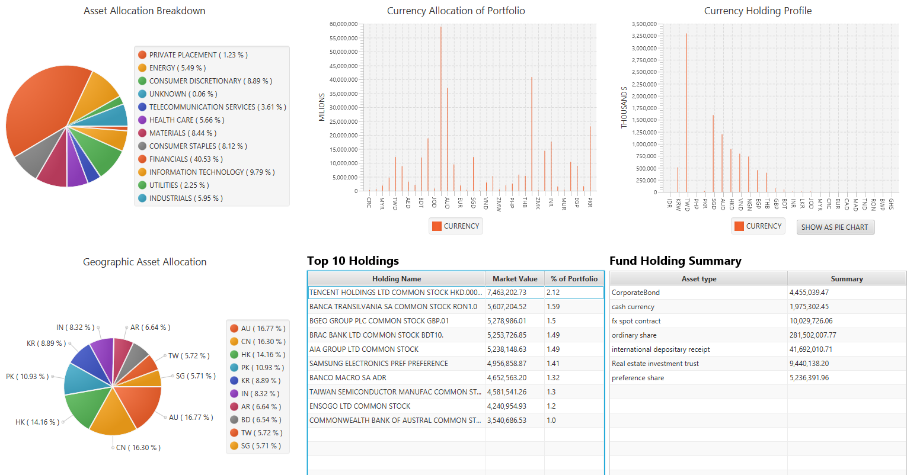

Figure 1: Managerial view of multiple funds aggregated using SPARQL and FIBO

### Example 2 Mapping Sources in Different Formats (Integration; reporting)

**Problem description:** “A FIBO Proof of Concept Team took a statistical data collection on a core banking balance sheet from the Bank of England and a regulatory collection used by both the Bank of England and Financial Conduct Authority. The first has an implicit, informal data model, described in an Excel template and an accompanying PDF of definitions. The second is defined by the European Banking Authority and comes in the form of a dimensional model, available both in an Access database format and an XBRL schema. We’d like to express them in a common format, in a manner that some banks and some third party software vendors can access them easily and map to them.”

Here the source formats are an Excel template and a dimensional data model. The same approach could be used for any two or more disparate data formats, or any two data models that are expressed in the same format but have different schemas.

The first step is to replicate these data formats in the RDF/OWL, using RDF/OWL Schema descriptions. FIBO itself is provided as an OWL model, which is also in the RDF/OWL format. The items in the data models are then mapped to the FIBO concepts.

Note that in most cases this is not a one-to-one mapping. One concept in a spreadsheet template or database may map to a unique combination of concepts in FIBO.

Usually, the concepts framed in a data model are highly contextual. So a simple data element like “Borrower phone number” would correspond to a set of classes and properties in the FIBO model. In FIBO, the information that makes up the context is itself part of the ontology. In this example, Loan Borrower Phone Number maps to a combination of the class of legal entity that may be a borrower, with the property for the phone number for any entity.

The basic requirement is that there is some framework in place in which semantic relationships may be asserted between the real world item as modeled in FIBO and the various data-specific representations of that item in the source data. These semantic relations can be extended to identify the specific kind of relationship in which some data element “represents” some real world thing or combination of things. There are also specialist tools that enable this kind of mapping.



# Appendix B Understanding SMIF UML Diagrams

SMIF based UML Class diagrams come in 4 types, as follows:

* Taxonomy diagrams showing the classification hierarchy of primary model content containing the concept
* Focus diagrams (per business domain, sub-domain; or per module or ontology file) showing the relationships of the concept to other concepts
* Defining diagrams establishing the precise semantics of the concept

#### Taxonomy Diagrams

A Taxonomy Diagram shows only the classification hierarchy of the class concepts that are of primary relevance in a given business domain or sub-domain. For example, a taxonomy of kinds of security will also show the types of contract that are kinds of. In the Taxonomy diagram below, *share* is shown as a kind of *transferable contract*.

For simplicity, some taxonomy diagrams show just one facet. For example, one diagram may show all derivatives classified by underlying asset type (rates, indices, commodities, foreign exchange, security assets and so on), while another may show all the same derivatives classified by contract structure (forward, options, swaps and swaptions). Where this is the case, users will find two or more adjacent taxonomy diagrams.

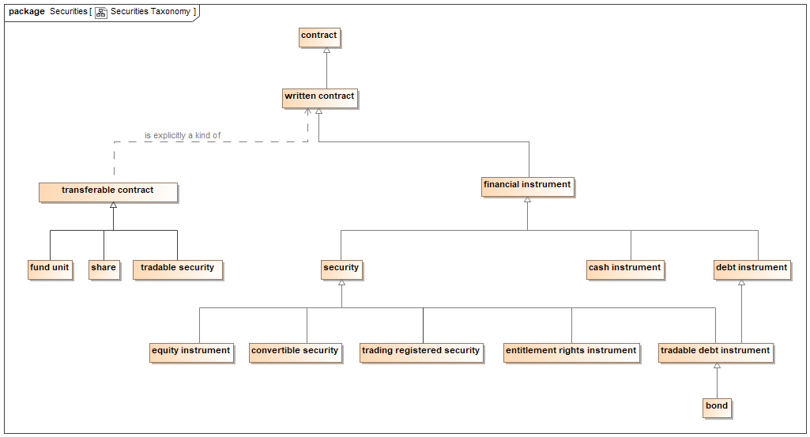

Most business domains, modules and ontologies contain additional subject matter besides the primary type of concept. For example, while the taxonomy may show the classification hierarchy of financial instruments, other concepts such as contract terms, cash flow descriptions and so on, are also in a taxonomic hierarchy of their own.

In summary, the taxonomy diagrams show all the information about the classification of the primary subject matter for a given business domain or sub-domain, in this example Securities.

#### Focus Diagrams

Focus diagrams are focused on some topic which may describe a whole business domain or a sub-domain. In the example below, the topic is Equity Instruments. Here, *share* is shown to be kind of *transferable contract* that may be privately held, or publicly traded. When it is publicly traded, it will also be a *registered security*.

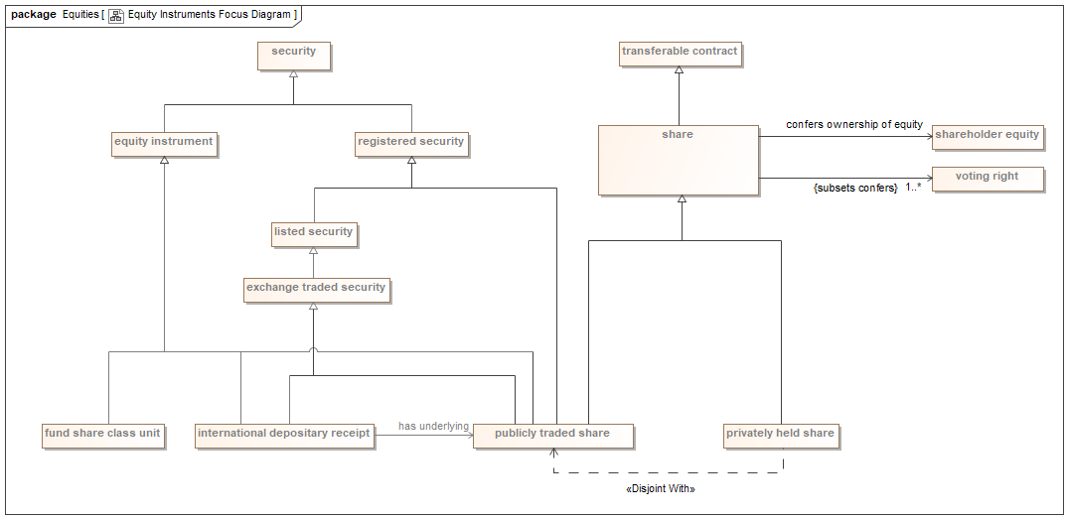

Some focus diagrams are provided for a specific ontology; in these cases, the diagram will usually show classes that are in other ontology files in a lighter color.

Some focus diagrams are color coded. These are generally used in subject matter expert reviews, where a range of concepts are of interest. The color coding is topical, that is to say all concepts relating to legal terms will be in one color, all concepts relating to numerical formulae will be another color, and so on.

Usually these focus diagrams (whether color or monochrome) will also include classes that are parents of the classes that are the focus of the diagram, along with relevant properties. For example, a diagram for bonds will also show debt instruments, traded debt instruments and securities, each of which introduces properties that are not unique to bonds but are inherited by them. These classes are generally shown in a lighter color. For the color diagrams, there is a lighter version of each color, in order to show these external concepts.

#### Defining Diagrams

Each concept that represents a class has a defining diagram. The defining diagram for a class shows all the properties that exist for that concept, along with any logical statements (called *“restrictions”*) that define membership of the class.

Properties are also concepts. The canonical definitions of a property concept are given on the defining diagram for the class which is the source (domain) for that property.

Some defining diagrams may be the defining diagram for more than one class; this is commonly the case when classes are closely inter-related and in the same ontology.

Concepts from other ontologies are shown in a lighter color. These may include parent classes, child classes, and classes that are the target (called the *range*) of a property. The FIBO diagram below for the concept *share* has most of these features, with the exception of child classes. The logical restrictions are shown as relationships with the annotation {subsets [name of the restricted property]}.

A screenshot of a cell phone

Description generated with very high confidence

# 5. Appendix C - Additional Training Materials

This section is intended to provide choices for learning about ontologies in general.

<https://www.cambridgesemantics.com/semantic-university/getting-started-semantics>

A text and video trip through all aspects of the semantic web and ontologies

<https://www.obitko.com/tutorials/ontologies-semantic-web/introduction.html>

Based on a PhD Thesis, begins with philosophy and then gets quite practical

<https://vimeo.com/66718408> RDBMS to RDF

A one hour slide show by Juan F. Sequeda of Capsenta as part of the Euclid Project

<http://www.linkeddatatools.com/semantic-web-basics>

Goes from the basics to many practical examples

<http://www.wiley.com/WileyCDA/WileyTitle/productCd-0470396792.html>

The Semantic Web for Dummies One of the original popular press writings

<https://www.amazon.com/Semantic-Web-Working-Ontologist-Second/dp/0123859654>

If you can study only one, this is it.

AND, if you are still unconvinced about the critical need for this technology, I suggest:

Software Wasteland: How the Application-Centric Mindset is Hobbling our Enterprises Paperback – February 6, 2018 https://www.amazon.com/Software-Wasteland-Application-Centric-Hobbling-Enterprises/dp/1634623169